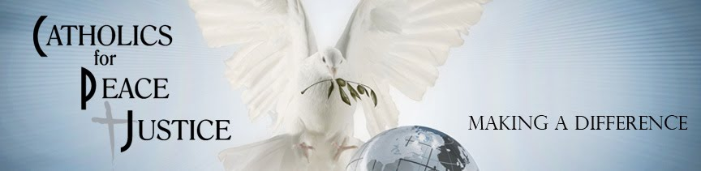
Catholics for Peace and Justice Immigration Education Needs Assessment

Catholics for Peace and Justice (CPJ) serves the greater Milwaukee area. CPJ is a Catholic Christian organization of laity and religious whose beliefs and actions are rooted in Sacred Scripture and Catholic Social Teaching. Catholic Social Teaching is the Church’s social vision that developed over time to address emerging social problems. http://www.catholicsforpeaceandjustice.org/home/our-pastors

CPJ is inviting you to complete this anonymous, voluntary, and confidential online survey to assess your needs for an immigration education program.

CPJ is asking for your help so we can respond to the needs of people in Christ-like way. Completing this survey will help us plan an immigration education program and to direct our work for justice.

CPJ will summarize the survey answers, no individual answers will be reported, only summaries. We will provide a written report of the results on the CPJ website.

Completing the survey indicates you choose to voluntarily participate. You do not need to answer any question you do not want to answer. If you know someone who might be interested in participating in this online survey, please share the survey link below with them.

You can access the survey with this link, https://survey.sogosurvey.com/Survey1.aspx?k=SsRQVVPWsQsPsPsP&lang=0

Please complete the survey within 5 days of receiving it.

If you have questions about this online survey please contact Catholics For Peace and Justice
Jim Gill, 414-708-4626, jfgill79@gmail.com
Or Marge Sebern, 262-375-2200, marge@sebern.com
Or Emer Martinez, 414-852-1803, emer.martinez1978@gmail.com

Thank you for helping Catholics for Peace and Justice Education committee respond to the needs of people in Christ-like way

